Course: Application Information and Communication Technology (Lab)

Semester: Spring 2025

Project Report

Submitted By:

|  |  |
| --- | --- |
| Name | Student ID |
| SYED AFNAN ALI | (751-2023) |
| SYED HAMZA AZIZ | (675-2023) |
| HAMMAD KHANZADA | (724-2023) |
|  |  |

Submitted To:

Lab Engineer: Miss Umama Saifullah

Submitted On:

12-June-2025

Project Title:

THE LAFLEUR DECOR (E-com)

Computing department, FCIT

Semester: 4st

|  |  |  |  |  |  |  |  |
| --- | --- | --- | --- | --- | --- | --- | --- |
| **Department**  **/ Faculty** | **Program** | **Semester** | **Course Title** | **Instructor** | **Issue Date** | **Due Date** | **Faculty Signature** |
| FCIT | BS  CS/ SE | 4st | AICT | Miss  Umama Saifullah |  |  |  |

Group Members:

1. SYED AFNAN ALI (751-2023)
2. SYED HAMZA AZIZ (675-2023)
3. HAMMAD KHANZADA (724-2023)

PROJECT ABSTRACT

**Lafleu Decor** is a back-end-focused flower shop project designed to support global operations. The system manages key features such as shopping cart functionality, session handling, and a contact page using a structured and secure database. The main focus of the project is on back-end logic rather than the user interface. It ensures that users can add or remove items from their cart, maintain their session during shopping, and send queries through a contact form, with all data being properly stored and managed in the database.

As a future improvement, since Lafleu Decor is planned on a global scale, shops can be set up in different countries. A feature can be added that allows users to select their country before placing an order, so they can shop and receive flowers from a nearby store based on their location.

Course: Application Information and Communication Technology (Lab)

Semester: SPRING-2025

Class: SE

Project Report

Project Title:

Submitted By:

|  |  |
| --- | --- |
| Name | Student ID |
| SYED AFNAN ALI | (751-2023) |
| SYED HAMZA AZIZ | (675-2023) |
| HAMMAD KHANZADA | (724-2023) |
|  |  |

Submitted To:

Lab Engineer: Miss Umama Saifullah

Submitted On:

12-June-2025

Computing department, FCIT

Semester: 4st

ACKNOWLEDGEMENT:

We are grateful to our Lab Instructor, **Miss Umama Saifullah**, for providing us with the tools, guidance, and knowledge necessary to complete this project. The **Lafleu Decor** website project focuses on backend development and is built using **PHP** for server-side functionality along with **HTML and CSS** for the interface. It includes essential backend features such as cart functionality, session handling, and a contact system. The system is designed to be simple, clean, and easy to understand.

Table of Contents:

|  |  |
| --- | --- |
| S No. | Name of Topic |
| 1 | Introduction |
| 2 | Problem Statement |
| 3 | Existing System |
| 4 | Amis and Objectives |
| 5 | Features of the project |
| 6 | Overall Description |
| 7 | Uml Representation of Project (Use Case & Activity Diagram) |
| 8 | Project Interfaces |
| 9 | Project Source Code |
| 10 | Conclusion And Future Work |

**Introduction:**

Lafleu Decor is an online flower shop project designed to manage and support the backend operations of a global e-commerce platform. The project is developed using PHP for backend logic, and HTML and CSS for the interface. The main focus is not on the user interface but on the core functionalities such as cart management, session handling, and a contact form, all connected to a secure and well-structured database. This system enables users to add products to their cart, maintain their session during the shopping process, and send inquiries through a contact page. The aim is to create a reliable backend structure that can support a smooth and efficient shopping experience for users around the world.

**Problem Statement:**

In the global flower market, one of the major challenges is the availability and delivery of rare flowers that are not commonly found in every country. While some flowers are easily available locally, others bloom only in specific regions or seasons, making it difficult for traditional online flower shops to fulfill such orders. This creates a gap in customer satisfaction and limits global accessibility.

The **Lafleu Decor** project addresses this problem by developing a backend system that can manage international orders, including those for rare flowers. The system allows users to select their country, and based on their location, it connects them to nearby suppliers or stores capable of fulfilling the order. With proper database management, the system keeps track of inventory, flower types, and regional availability to ensure that even rare flowers can be sourced and delivered efficiently.

**Existing System:**

Most flower websites today sell only common flowers. They don’t offer rare flowers that are hard to find. Also, many of these websites are basic and don’t work like real online stores.

They don’t have features like shopping carts, session handling, or working contact forms. Customers can’t save items, and their data is not handled properly. Some websites don’t even allow users to contact the seller easily.

These problems happen because many sites are made only with HTML and CSS. They don’t use backend coding like PHP or databases like MySQL. This makes the system slow, manual, and not user-friendly.

That’s why there is a need for a better system like **LaFleur Décor**, which solves these problems by offering rare flowers and full backend features.

**Aims and Objectives:**

### ****Aims and Objectives****

The main aim of this project is to build an online flower-selling website that offers **rare flowers** to customers all over the world. The website will be user-friendly and connected to nearby flower shops and agents who supply these rare flowers.

#### ****Objectives:****

1. **Sell rare flowers online** that are not easily available in the local market.
2. **Work with special agents** who help us find and provide these rare flowers.
3. **Connect the system with nearby flower shops** to make delivery faster and easier.
4. **Create a simple and beautiful design** using HTML and CSS.
5. **Use PHP and MySQL** for backend work like saving orders, customer details, and contact messages.
6. **Add a shopping cart system** where customers can add or remove flowers before checkout.
7. **Handle user sessions** so each customer can safely use the website during their visit.
8. **Build a working contact form** so users can easily send messages or ask questions.
9. **Make the site mobile-friendly** so it works well on phones and other devices.

**Features of the project:**

LaFleur Décor is a unique online flower shop that specializes in selling rare and hard-to-find flowers. It works closely with trusted agents who help source these special flowers and connects with nearby flower shops to ensure faster delivery and better customer service. The website is designed with a user-friendly interface using HTML and CSS, making it easy for customers to browse and shop. It includes a shopping cart system where users can add, update, or remove flowers before checkout, and session handling keeps track of their activities securely throughout their visit. Customers can easily contact the shop through a working contact form to ask questions or send feedback. The backend is built using PHP and MySQL to safely manage products, orders, user information, and messages. Additionally, the site is fully responsive, providing a smooth experience on desktops, tablets, and mobile devices. The admin panel allows easy management of orders and flower availability, making the entire system efficient and reliable

**Overall Description:**

LaFleur Décor is an eCommerce website dedicated to selling rare and unique flowers worldwide. The system is designed to provide a seamless online shopping experience through an attractive and easy-to-use interface built with HTML and CSS. Behind the scenes, PHP and MySQL work together to manage user sessions, shopping carts, orders, and customer messages securely and efficiently. The website connects with trusted agents who source rare flowers and nearby flower shops to help with faster delivery. Customers can browse flowers, add them to their cart, and place orders confidently. The contact form allows customers to communicate directly with the shop for any questions or support. The responsive design ensures the website works smoothly across all devices, including mobile phones and tablets. The admin panel helps manage products, orders, and customer requests, making LaFleur Décor a reliable and professional platform for rare flower sales worldwide.

**Uml Representation of Project (Use Case & Activity Diagram):**

**USE CASE DIAGRAM:**

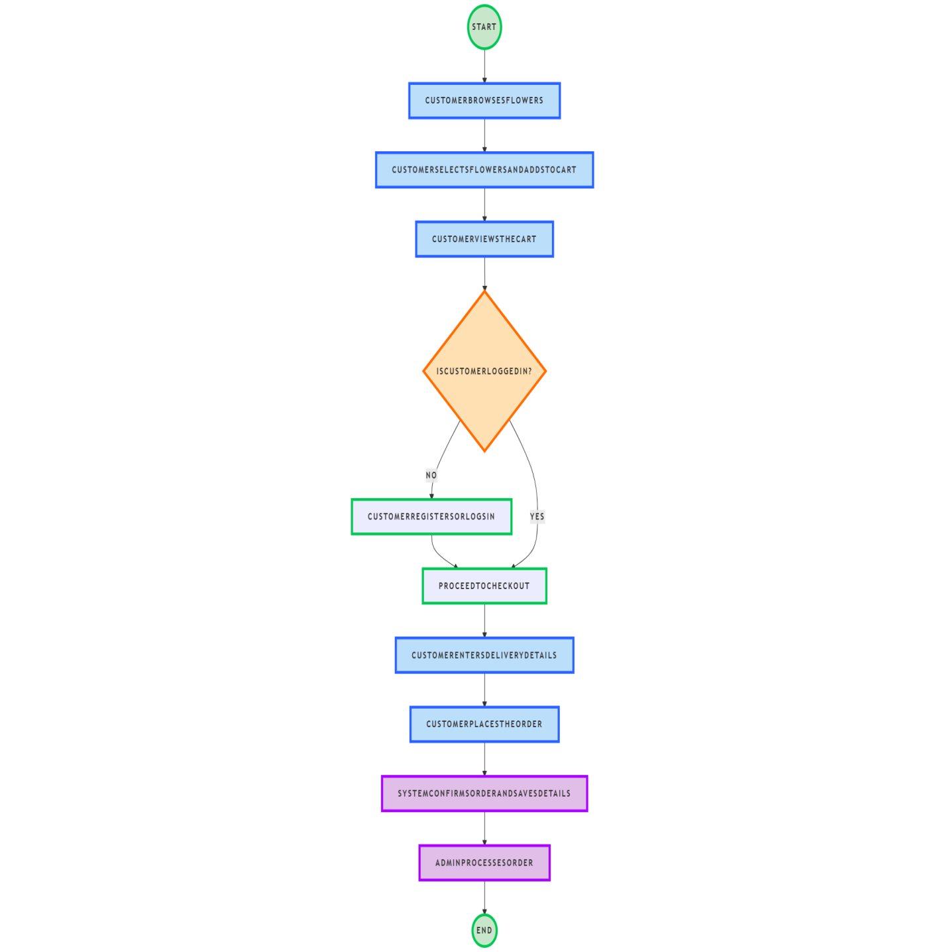

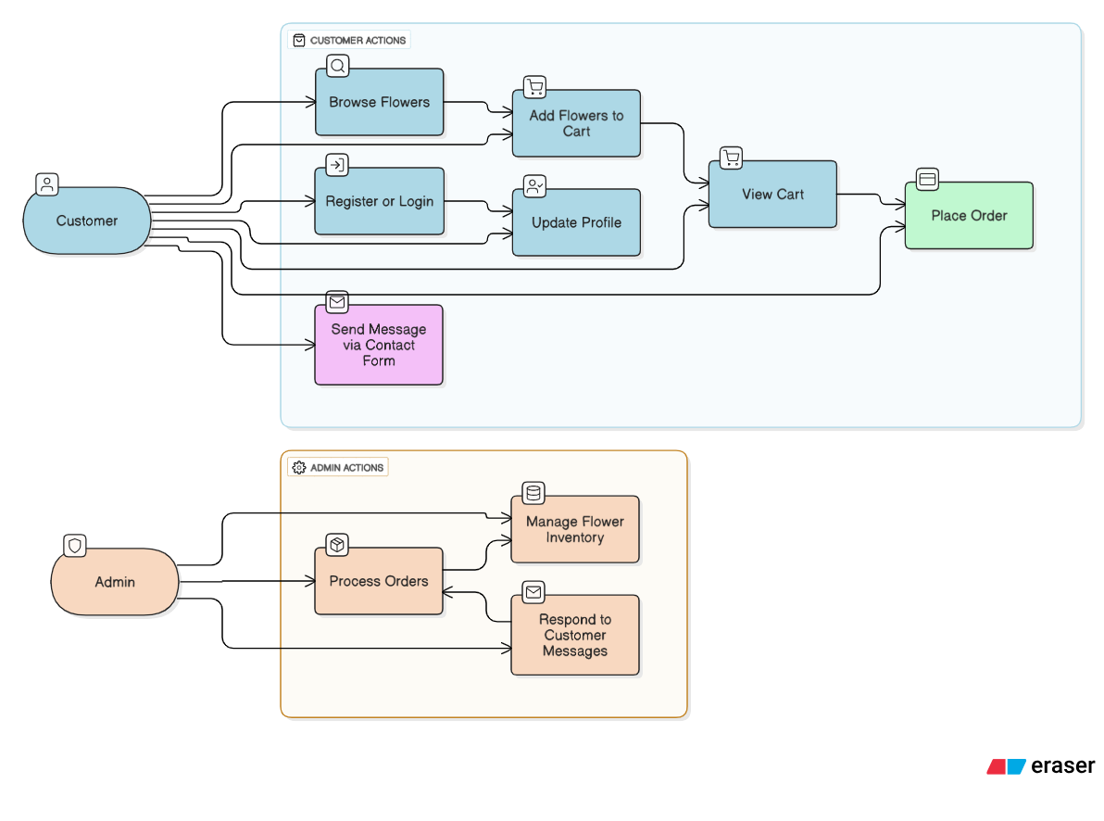

**Project Interfaces:**

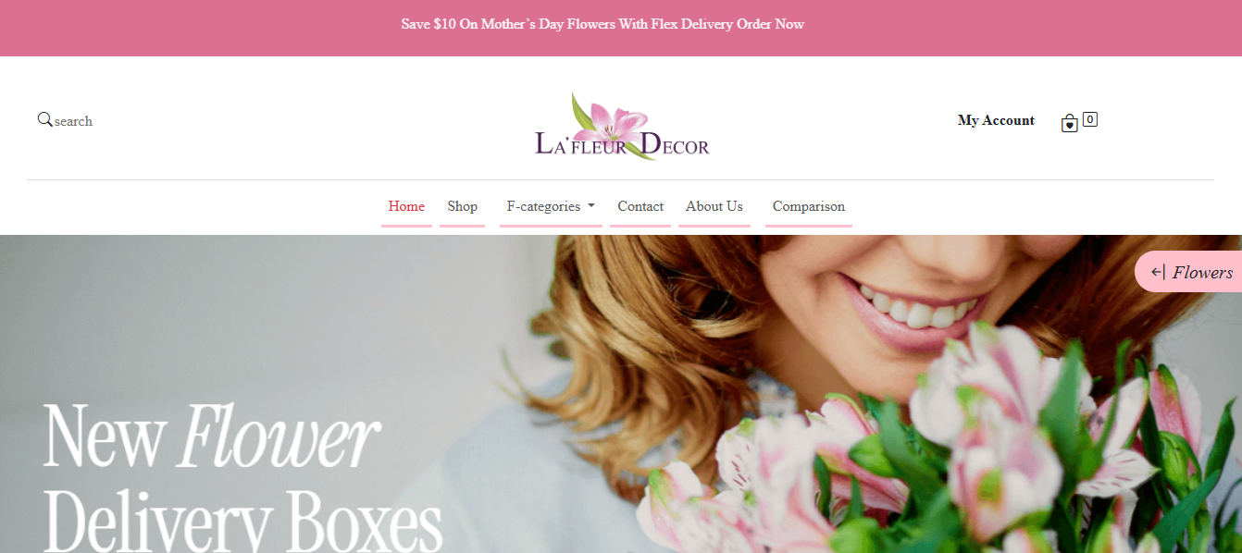

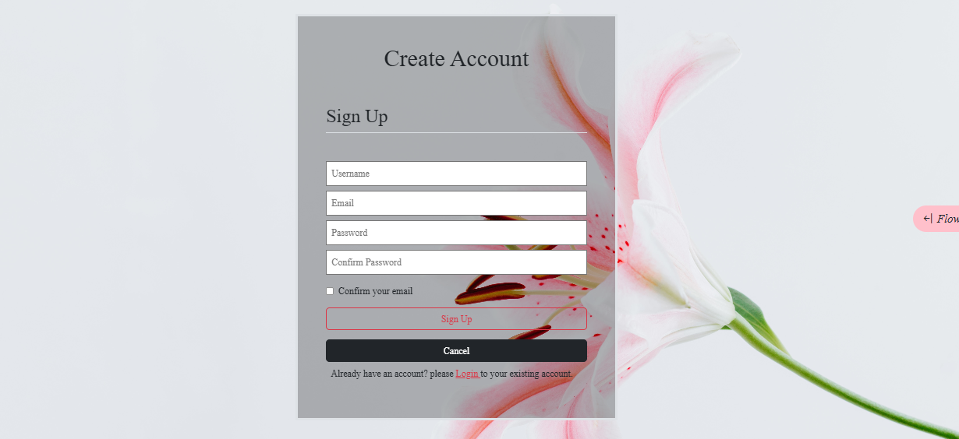

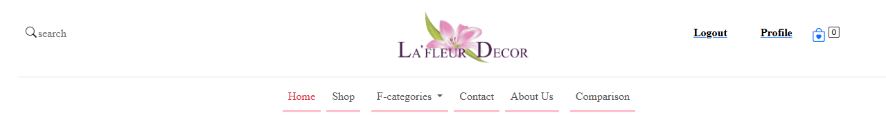

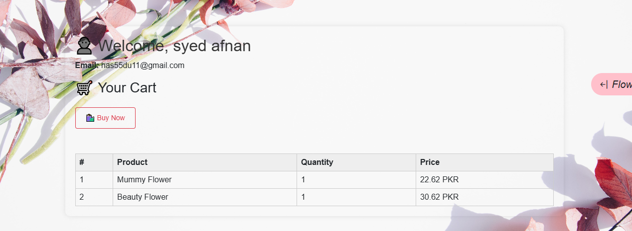

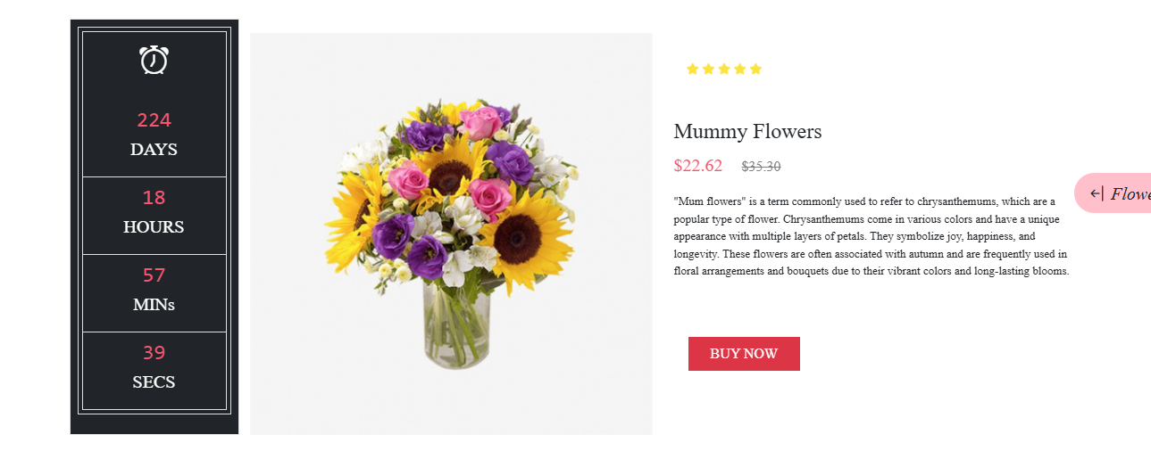

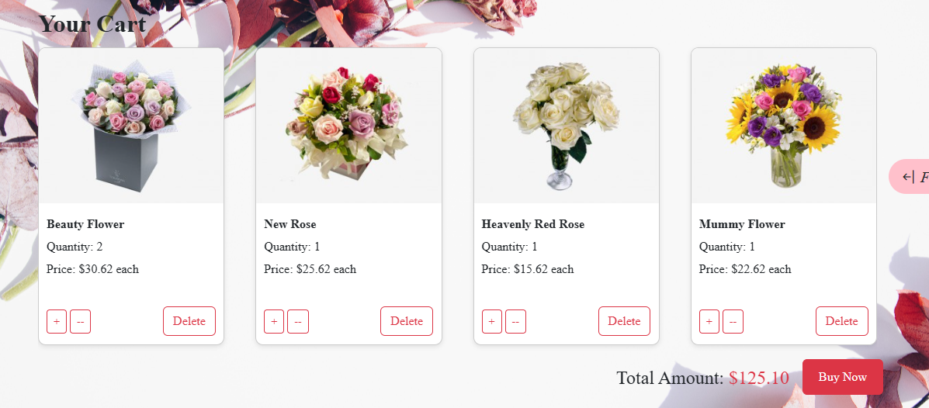

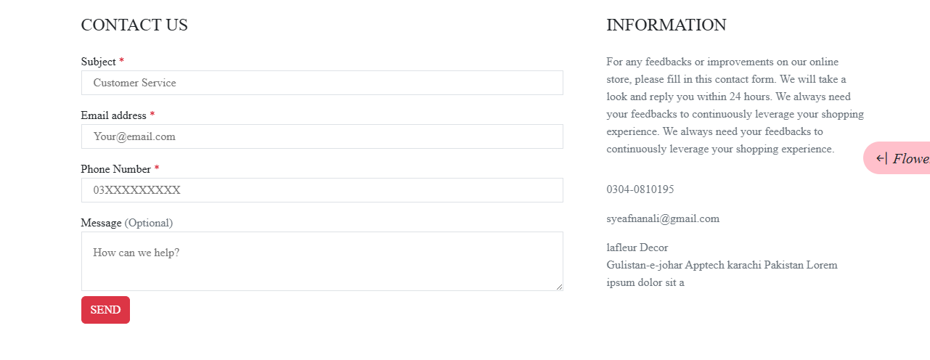

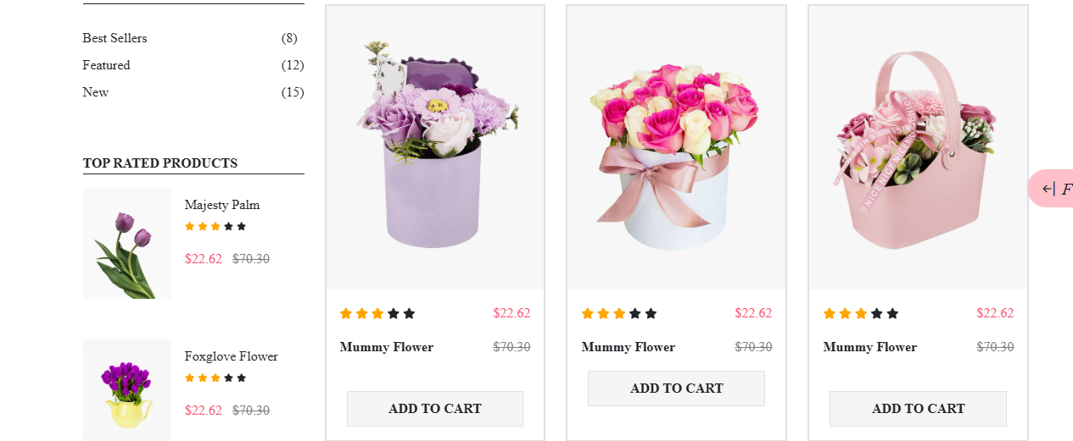

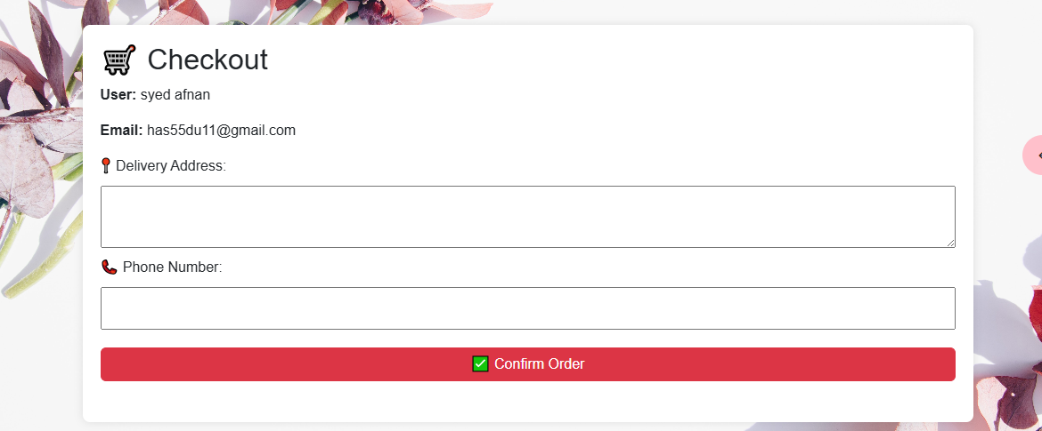



**Project Source Code:**

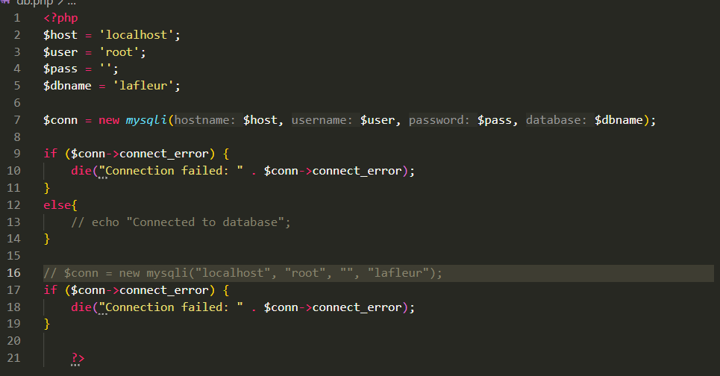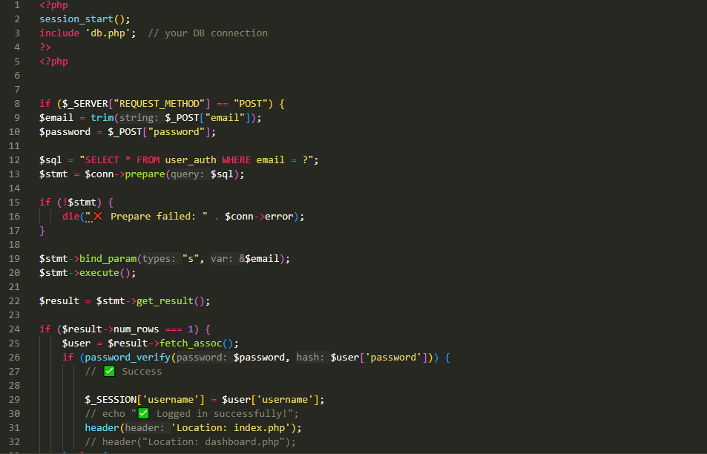

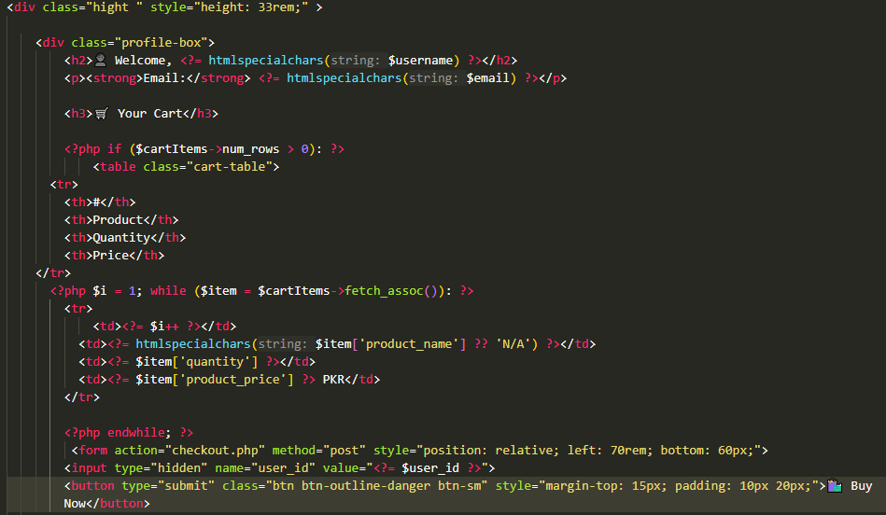

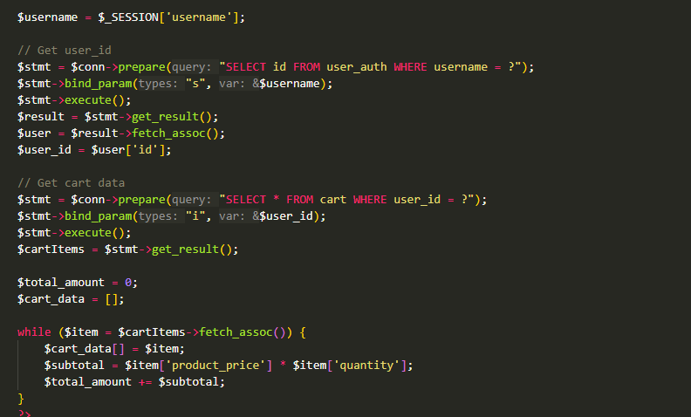

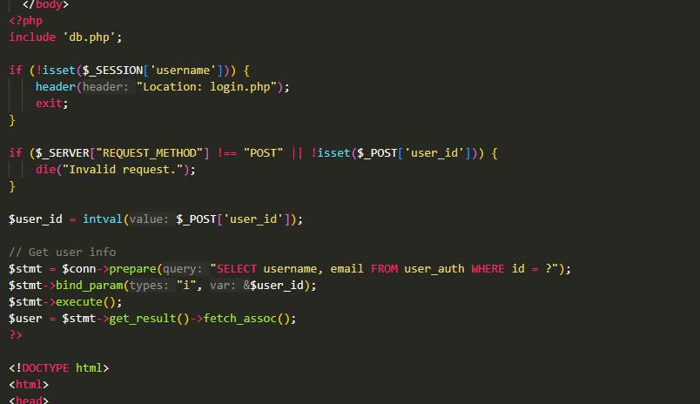

**Conclusion And Future Work:**

In conclusion, the LaFleur Décor project successfully creates an online platform for selling rare flowers worldwide. The system includes important features such as a shopping cart, session handling, and a working contact form, which improve the shopping experience and make the website reliable and easy to use. By connecting with agents and nearby flower shops, it ensures availability and timely delivery of rare flowers.

For future work, the project can be enhanced by adding features like online payment integration, real-time order tracking, customer reviews, and a mobile app version. These improvements will make the platform even more user-friendly and efficient, helping LaFleur Décor grow and serve more customers around the world.